**JMeter User Guide**

To setup JMeter, We need to download JMeter([apache-jmeter-3.2.zip](https://archive.apache.org/dist/jmeter/binaries/apache-jmeter-3.2.zip)) s/w from <https://archive.apache.org/dist/jmeter/binaries/>

The Below list of JARS are required to run our scripts in ChromeDriver.

* JMeterPlugins-Extras-1.4.0
* JMeterPlugins-ExtrasLibs-1.4.0
* JMeterPlugins-Standard-1.4.0
* JMeterPlugins-WebDriver-1.4.0

For configuring we need to extract the above JARS and place it **lib** and **ext** folders in JMeter respectively.

* Now start up a JMeter tool, Go to **apache-jmeter-3.2\bin** directory and Click on jmeter.bat file

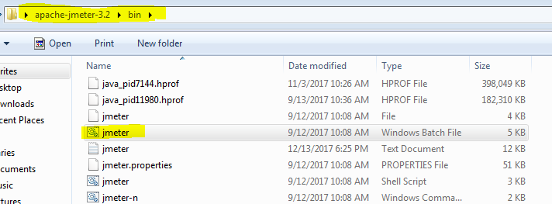

* Now we will see JMeter tool window

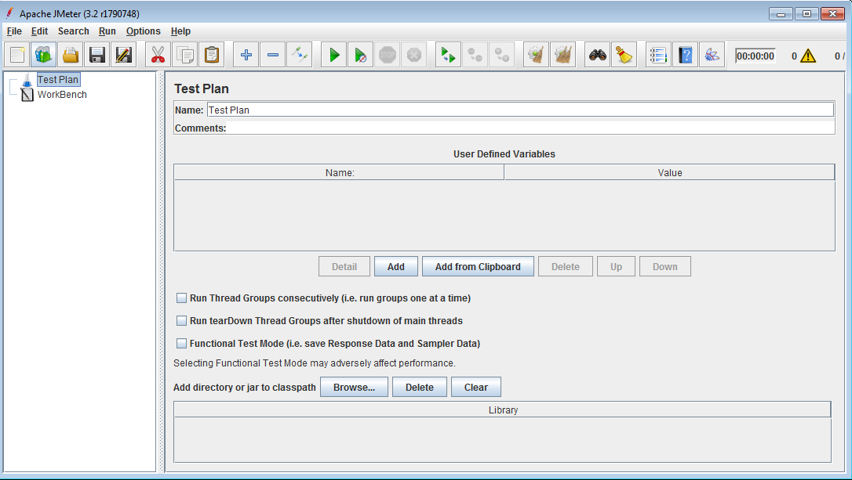

Go to File 🡪 Open 🡪 add Existing script

